Module Name:Practice Test Automation - Black Box, White Box, Integration & System Testin
Test Case ID: st_09
Webpage URL:https://practicetestautomation.com/logged-in-successfully

● Scenario ID: 1a

Scenario: Login with valid credentials
Test Steps:
- Enter username
- Enter password
- Click Login
Screenshots:
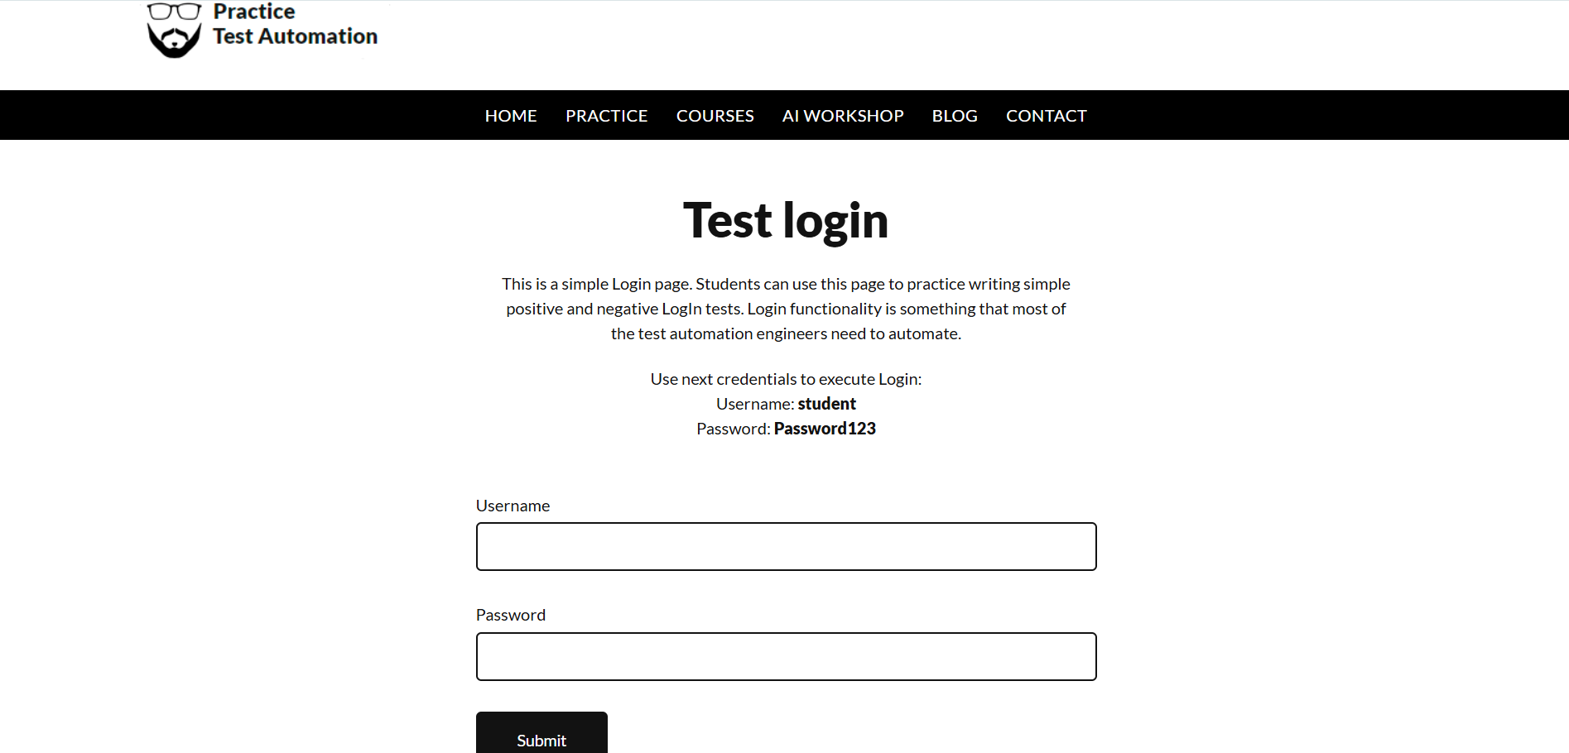
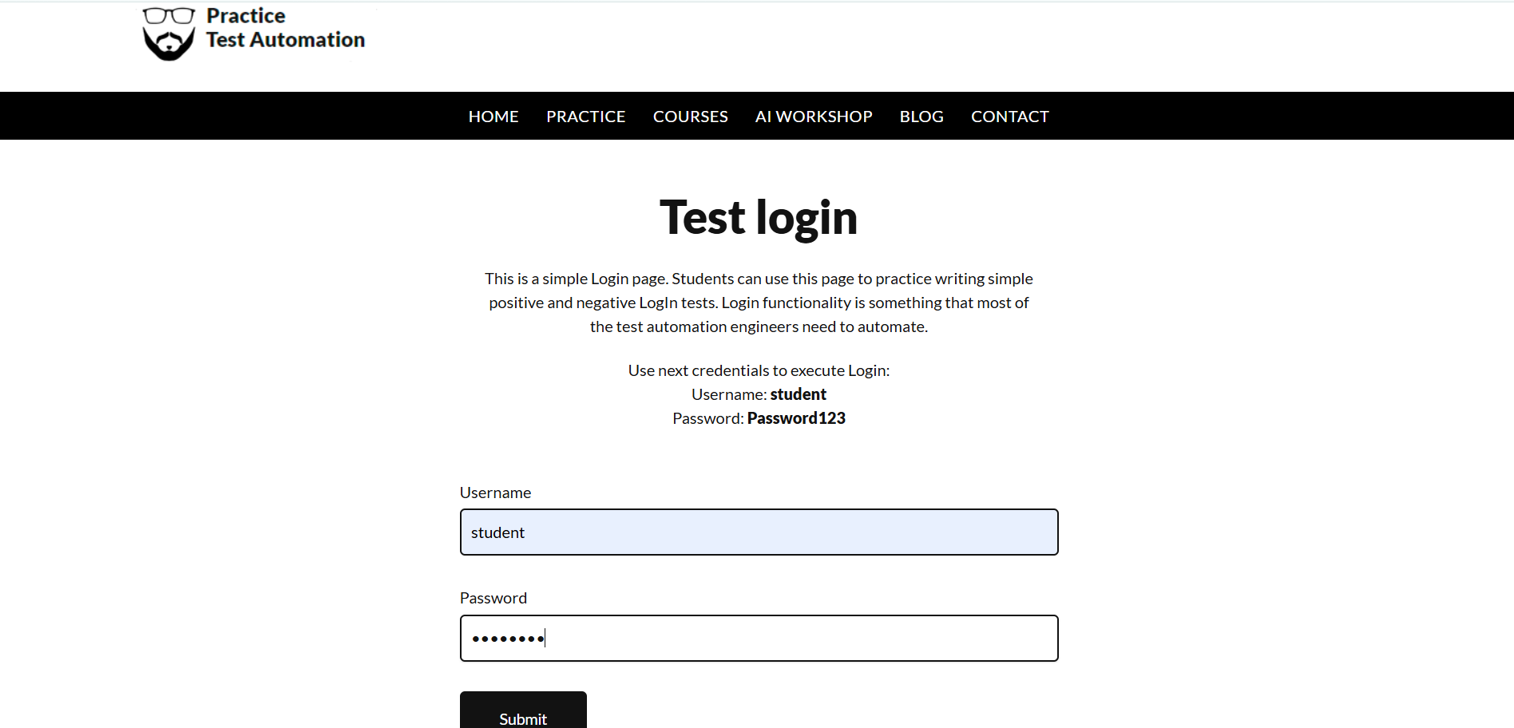
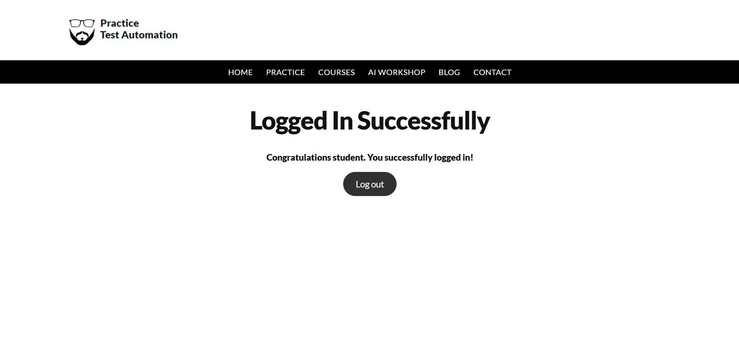
Actual Result :- Successful Login
Status:- Pass

● Scenario ID: 1b

Scenario: Login with invalid Password
Test Steps:
- Enter username
- Enter invalid password
- Click Login
Screenshots:
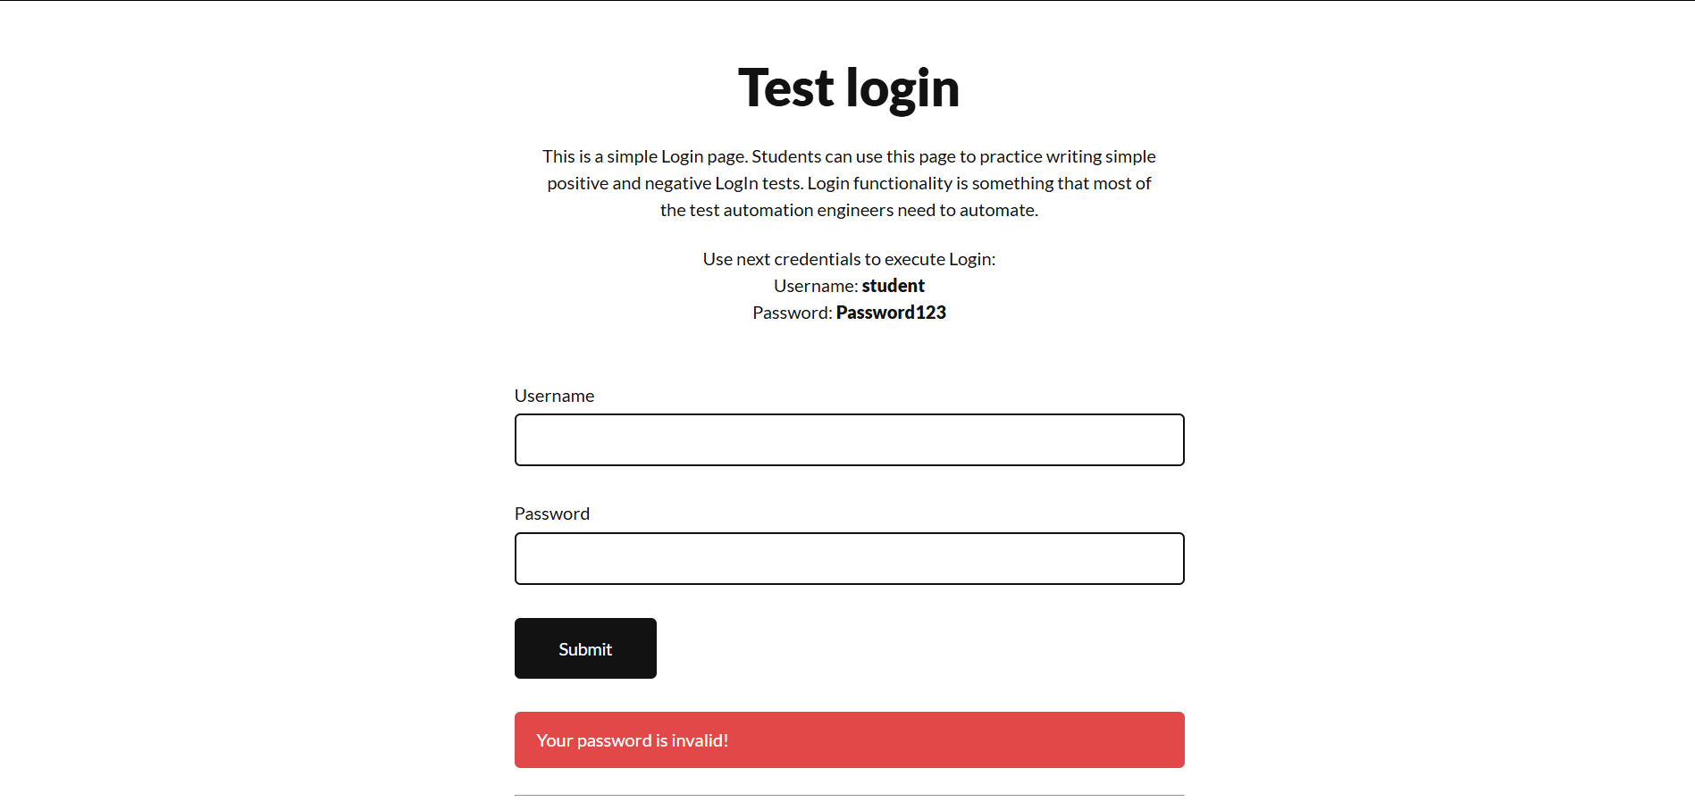

Actual Result :- Error shown
Status:- Pass

● Scenario ID: 1c

Scenario: Login with invalid username
Test Steps:
- Enter invalid username
- Enter password
- Click Login
Screenshots:
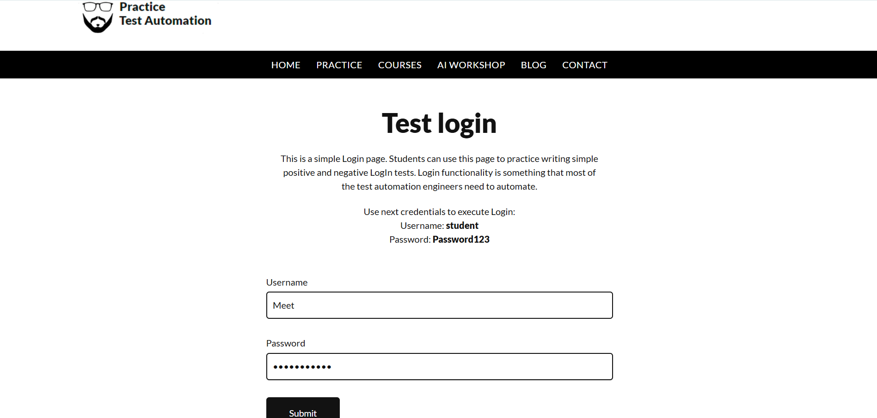
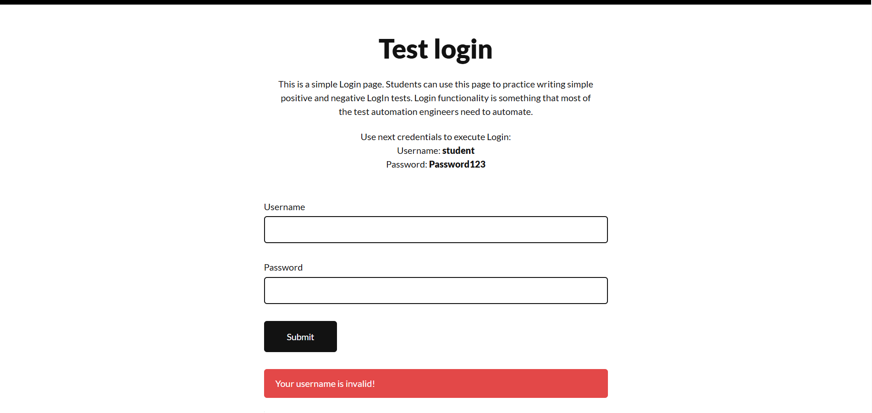

Actual Result :- Error shown
Status:- Pass

Scenario ID: 1d

Scenario: Login with both invalid
Test Steps:
- Enter invalid username
- Enter invalid password
- Click login
Screenshots:

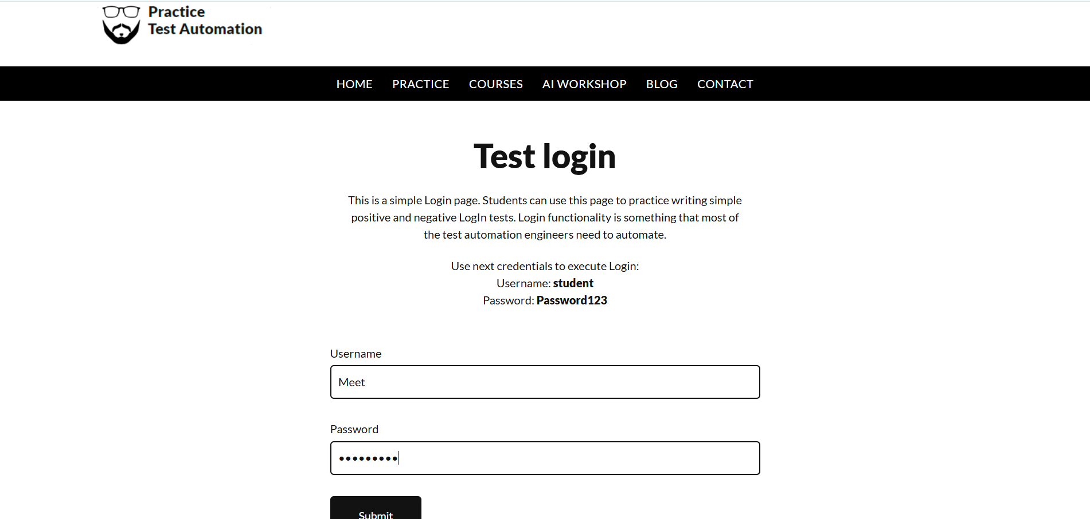
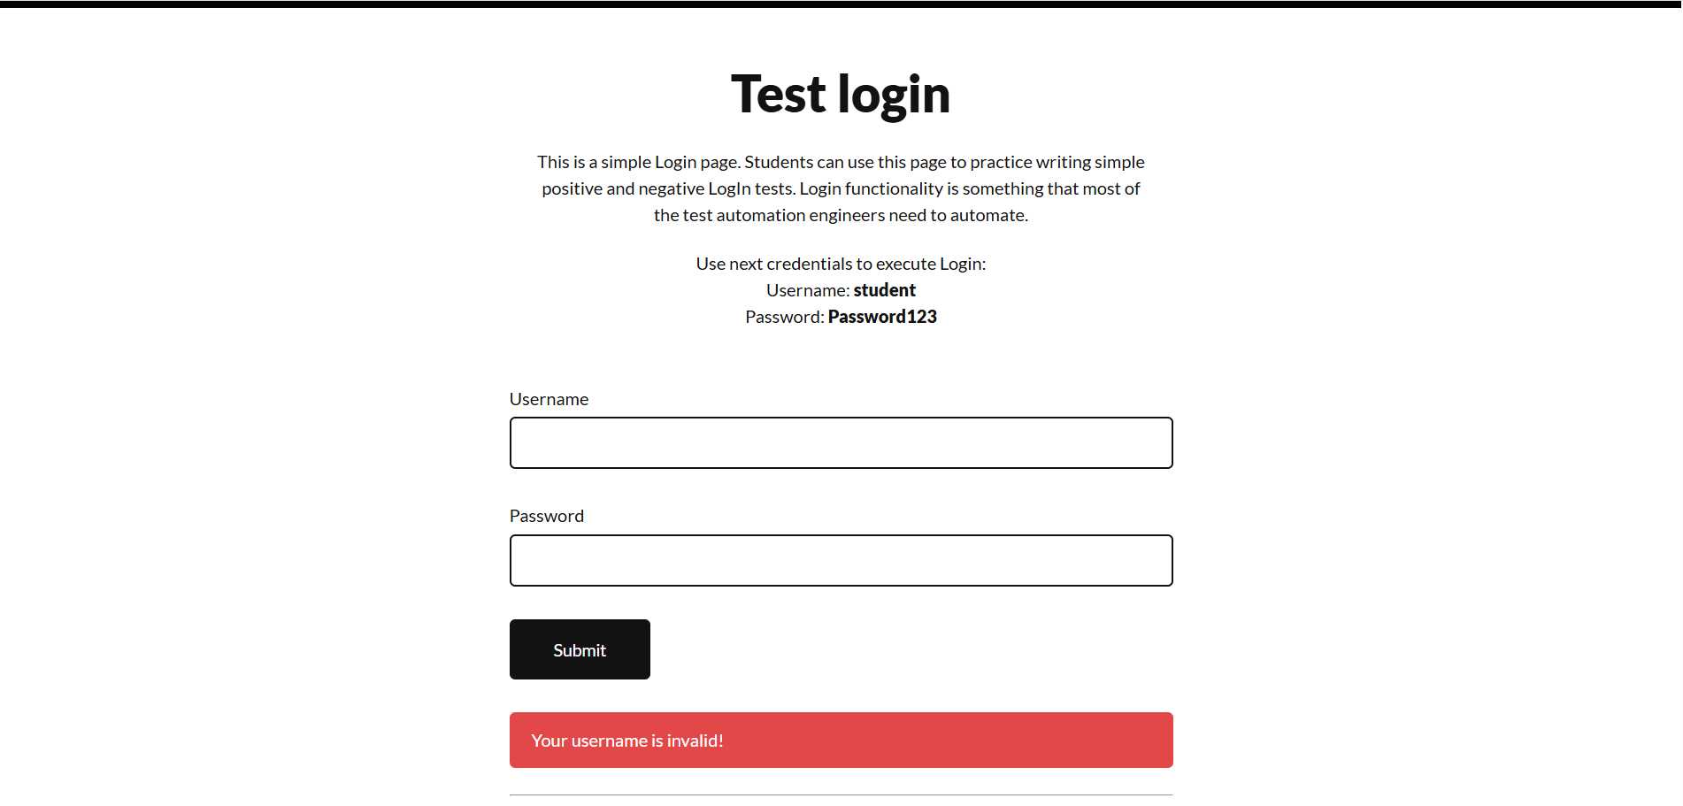

Actual Result :- Error shown
Status:- Pass

● Scenario ID: 1e

Scenario: Try Login with empty username
Test Steps:
- Enter username
- Blank password
- Click Login
Screenshots:
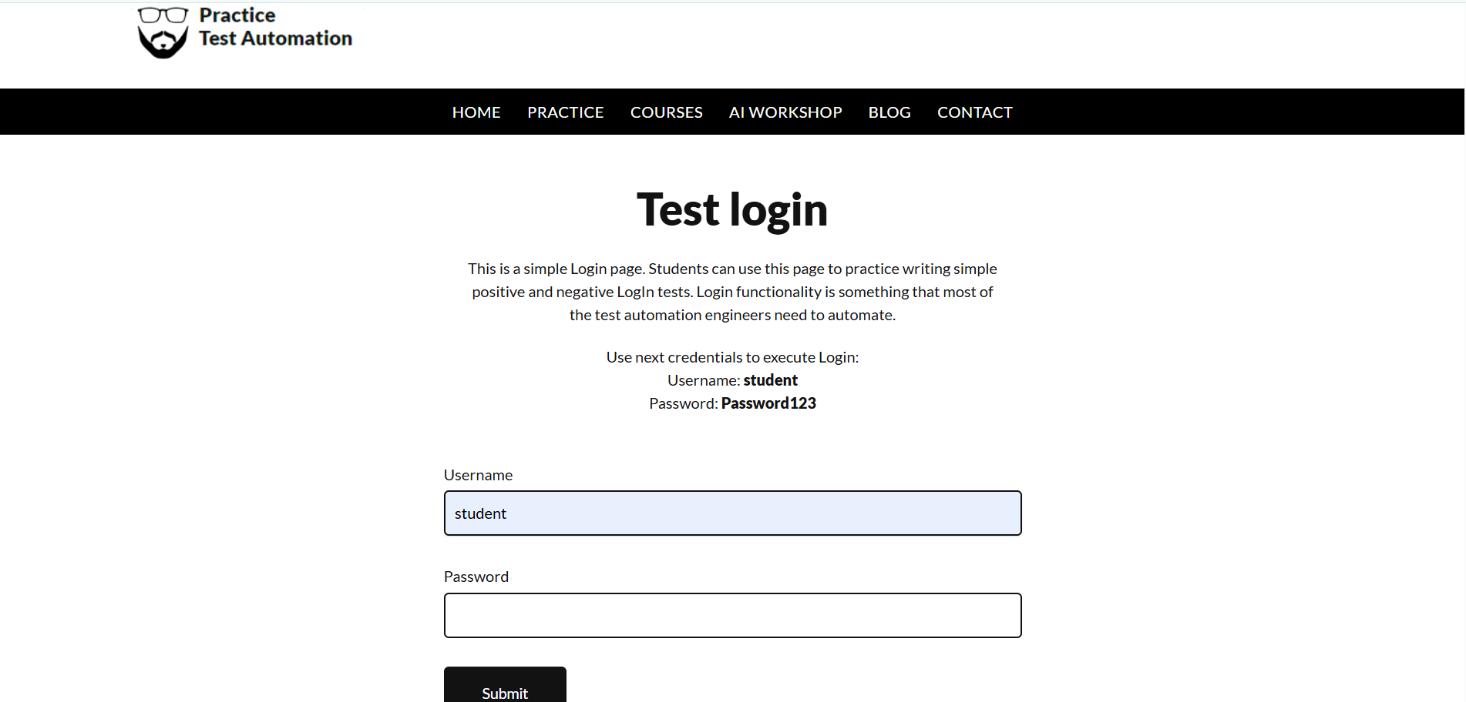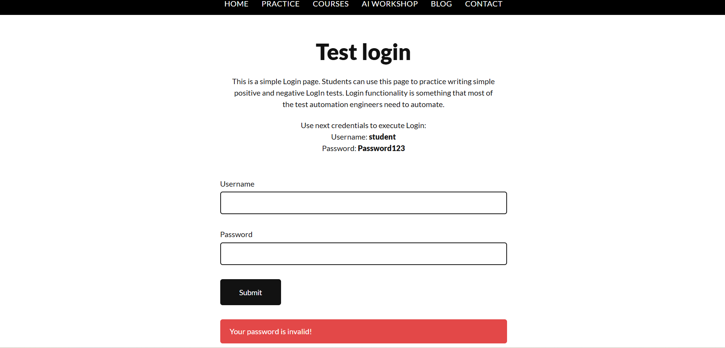

Actual Result :- Error shown
Status:- Pass

Scenario ID: 1f

Scenario: Try Login with empty password
Test Steps:
- Blank username
- Enter password
- Click Login
Screenshots:
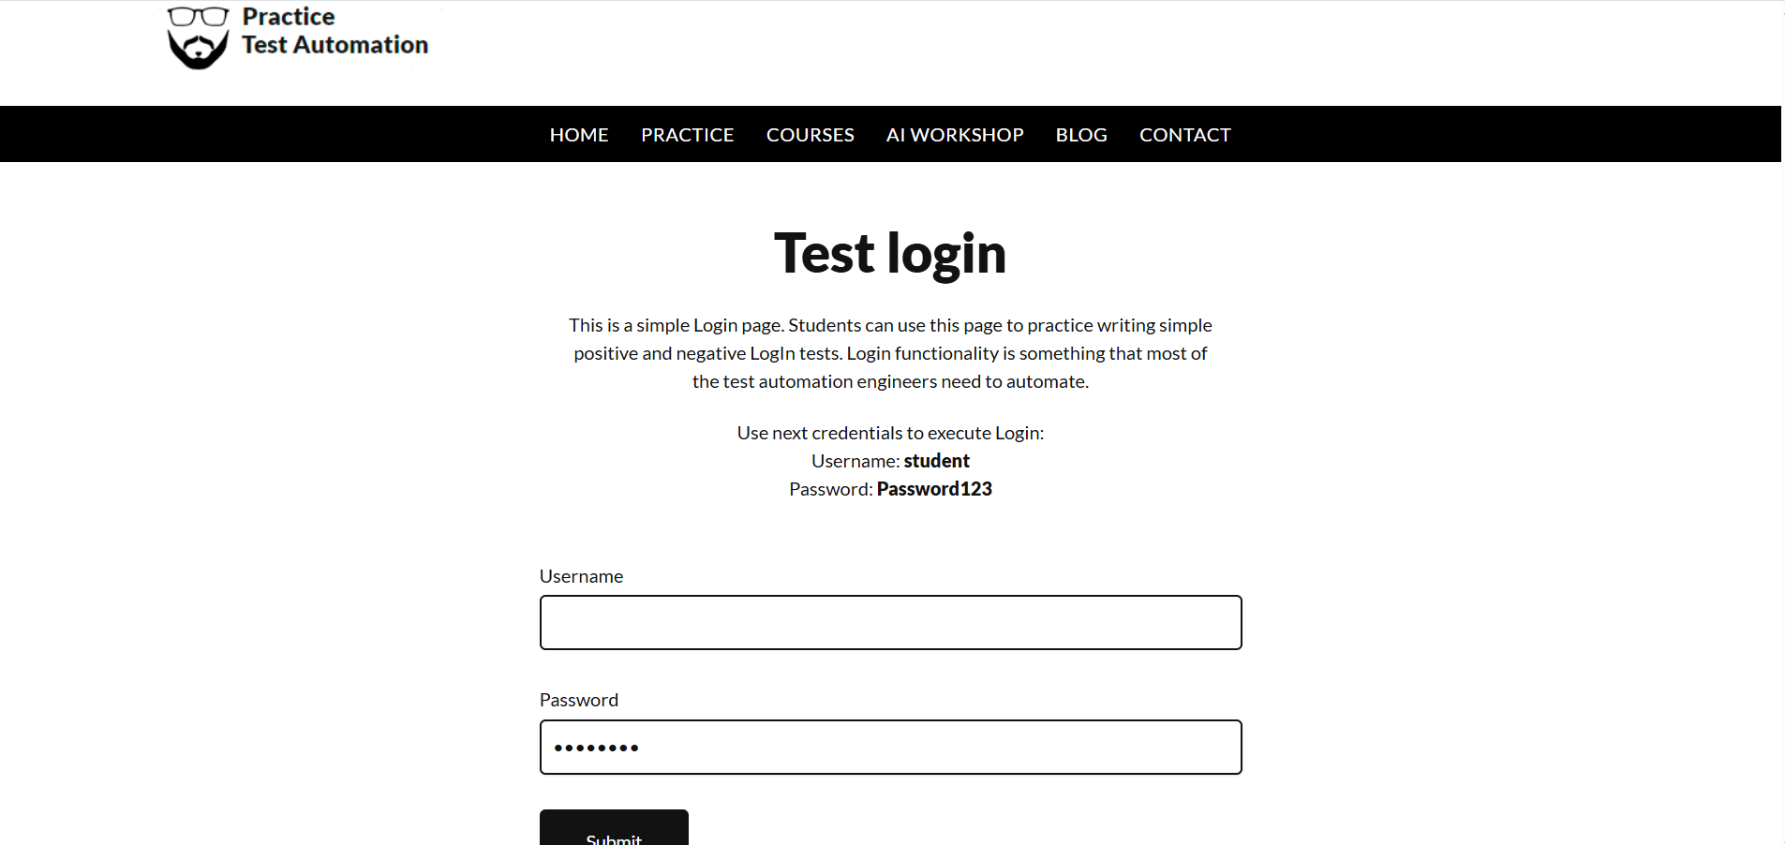
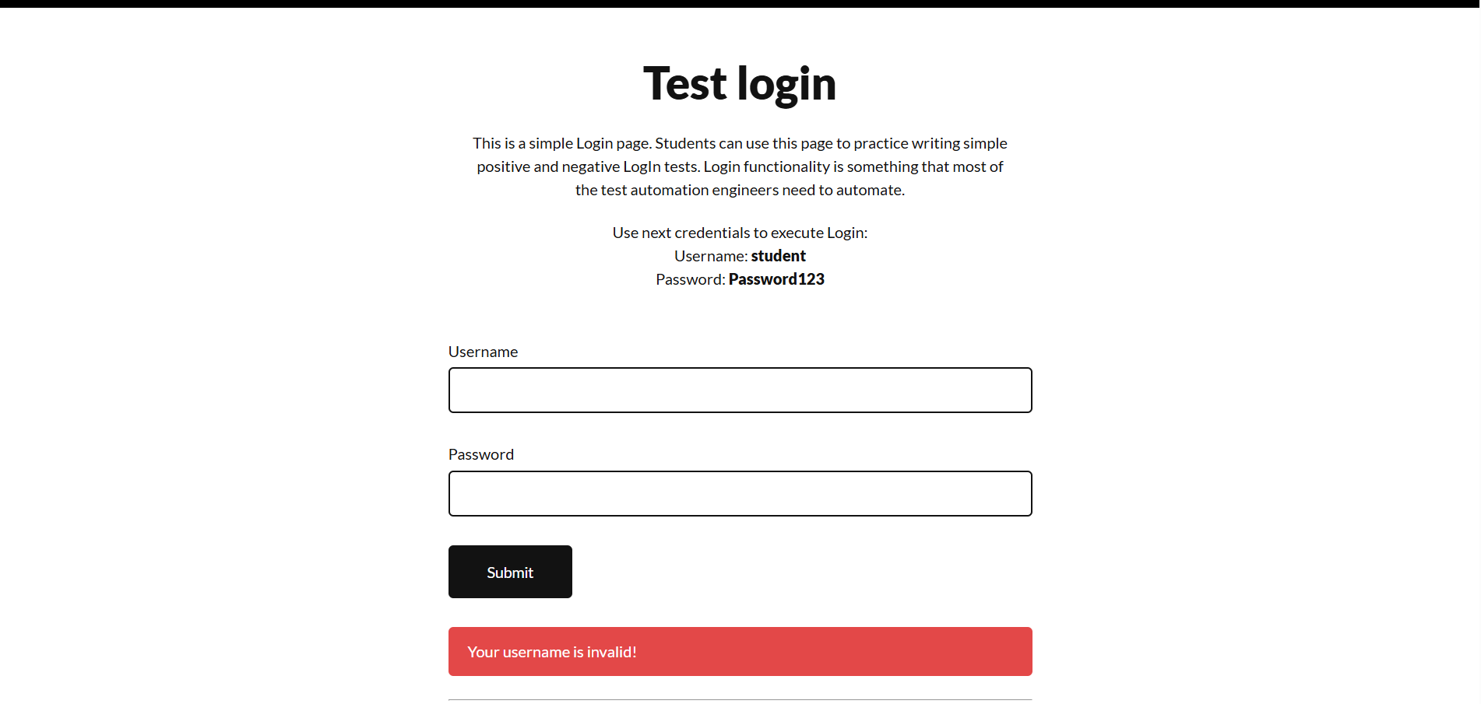

Actual Result :- Error shown
Status:- Pass

Scenario ID: 1g

Scenario: Try login with both blank
Test Steps:
- Blank username
- Blank password
- Click Login
Screenshots:
Actual Result :-Successfull Logout
Status:- Pass

